EXERCISE #3

CODE
'CS375 COMPUTER EXERCISE #3
'This program is written in Visual Basic 6.0 code. You are to create a console version and a
'GUI version in Visual Basic .Net.
Public Class frmBackpack
Inherits System.Windows.Forms.Form
Private Sub btnCompute_Click(ByVal sender As Object, ByVal e As System.EventArgs) Handles btnCompute.Click
Dim bounces As Integer, height As Integer, bouncefactor As Double, _
distance As Double, btype As String
height = txtHeight.Text
If (txtType.Text > 0) And (txtType.Text < 5) Or Not (txtType.Text = "") Then
bouncefactor = Microsoft.VisualBasic.Switch(txtType.Text = 1, 0.7, _
txtType.Text = 2, 0.75, _
txtType.Text = 3, 0.9, _
txtType.Text = 4, 0.3)
btype = Microsoft.VisualBasic.Switch(txtType.Text = 1, " Tennis Ball ", _
txtType.Text = 2, " Basketball ", _
txtType.Text = 3, " Super Ball ", _
txtType.Text = 4, " Softball ")
height = height * 100
bounces = 1
While height * bouncefactor >= 10
bounces = bounces + 1
height = height * bouncefactor
distance = distance + 2 * height
End While
lstOut.Items.Add("The " & btype & " bounced " & bounces & " times.")
lstOut.Items.Add("The " & btype & " traveled about " & distance / 100 & "meters.")
Else
MsgBox("You must enter one of the following values: 1,2,3,4", , "Data Entry")
txtType.Clear()
lstOut.Items.Clear()
txtType.Focus()
End If
End Sub
Private Sub btnClear_Click(ByVal sender As Object, ByVal e As System.EventArgs) Handles btnClear.Click
lstOut.Items.Clear()
txtHeight.Clear()
txtType.Clear()
txtHeight.Focus()
End Sub
Private Sub btnExit_Click(ByVal sender As Object, ByVal e As System.EventArgs) Handles btnExit.Click
Me.Close()
End Sub
Private Sub frmBackpack_Load(ByVal sender As System.Object, ByVal e As System.EventArgs) Handles MyBase.Load
With lstInput.Items()
.Clear()
.Add("1. Tennis Ball")
.Add("2. Basketball")
.Add("3. Super Ball")
.Add("4. Softball")
End With
End Sub
Private Sub tmr1_Tick(ByVal sender As System.Object, ByVal e As System.EventArgs) Handles tmr1.Tick
lblTimer.Text = Now
End Sub
End Class

GUI INTERFACE
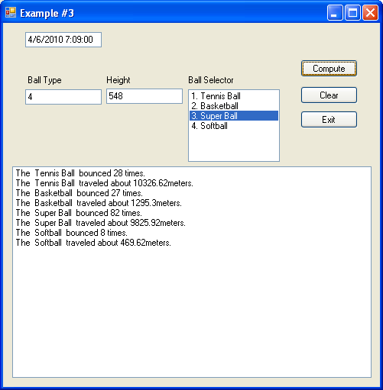
EXERCISE #4
CONSOLE CODE
'CS375 COMPUTER EXERCISE #4
'This program is written in Visual Basic .Net console environment. You are to write a GUI
'version in Visual Basic .Net.
Module Triangle
Sub Main()
Dim row As Integer = 1, side, column, a, b As Integer
Console.Write("Enter side length(must be 20 or less): ")
side = Console.ReadLine
a = side
b = side
If side <= 20 Then
While row <= side
column = 1
While column <= row
Console.Write("*")
column += 1
End While
Console.WriteLine()
row += 1
End While
Console.WriteLine("--------------------")
row = 1
While side >= row
column = 1
While column <= side
Console.Write("*")
column += 1
End While
Console.WriteLine()
side -= 1
End While
Console.WriteLine("--------------------")
side = a
row = 1
While row <= side
column = 1
While column < row
Console.Write(" ")
column += 1
End While
a = side
While a >= row
Console.Write("*")
a -= 1
End While
Console.WriteLine()
row += 1
End While
Console.WriteLine("--------------------")
row = 1
side = b
While row <= side
column = side
While column > 0
Console.Write(" ")
column -= 1
End While
a = 1
While a <= row
Console.Write("*")
a += 1
End While
Console.WriteLine()
row += 1
End While
Else
Console.WriteLine("side too large")
End If
End Sub
End Module

CONSOLE INTERFACE
